A Project Report on

**E-Commerce Platform**

**Submitted in partial fulfillment of the degree of  
Bachelor of Computer Applications**

**VI Semester**

Submitted by

**Ramjivan Jangid**

**Kunal Awasthi**

**Kuldeep Jangid**

Under the Supervision of  
**Dr. Arpita Mathur**

Faculty of Computer Science



**Faculty of Computer Science  
Lachoo Memorial College of Science & Technology (Autonomous)**

**Jodhpur**

*2018*



##### **Faculty of Computer Science**

**Lachoo Memorial College of Science & Technology (Autonomous)**

# CERTIFICATE

This is to certify that the System Design Project entitled

**E-Commerce Platform**

has been designed and developed by

**Ramjivan Jangid**

**Kunal Awasthi**

**Kuldeep Jangid**

in partial fulfillment of the degree of BCA VI Semester Examination 2018, under my supervision and guidance.

**Prof. (Dr.) Priyadarshi Patni Dr. Arpita Mathur**

Director Designation,

Faculty of Computer Sc Faculty of Computer Sc

Date:

**Acknowledgement**

*The success and final outcome of this project required a lot of guidance and assistance from many people and I am extremely privileged to have got this all along the completion of our project. All that We have done is only due to such supervision and assistance and We would not forget to thank them.*

*We respect and thank Dr. Arpita Mathur, for providing us the supervision and guidance at many times throughout project lifecycle which made us complete the project duly. We are extremely thankful to* ***Lachoo Memorial College of Science and Technology*** *for providing such a great Academics that were based on many interpersonal and intrapersonal skills.*

*I owe my deep gratitude to our project guide, who took keen interest on our project work and guided us all along, till the completion of our project work by providing all the necessary information for developing a good system.*

*We would not forget to remember our Parents and Faculties from College for their encouragement and more over for their timely support and guidance till the completion of our graduation programme and project work.*

***Students Names***

*Ramjivan Jangid*

*Kunal Awasthi*

*Kuldeep Jangid*

**Contents**

| 1. Introduction |  |
| --- | --- |
| 1. Recognition of Need |  |
| 1. Existing System with Limitations |  |
| 1. Proposed System with Advantages |  |
| 1. Process/Working |  |
| 1. Feasibility Study |  |
| 1. Data Flow Diagrams |  |
| 1. E R Diagram and Database Tables |  |
| 1. Project Design (Screenshots) |  |
| 1. Future Enhancement |  |
| 1. Conclusion |  |
| 1. References |  |
| Appendix |  |

# 1. Introduction

The E-Commerce project is a Electronic Commerce Project. It enables a Local Business to setup a web store in easy steps. an Merchants can showcase their at common store for all & also can request/setup a separate web store.

The Objective of project is to portrait the fundamentals of e-commerce that are stated below :-

* An **online electronic catalog** listing all products for sale, their price and sometimes their availability (product in stock or number of days before delivery);
* **search engine** which makes it possible to easily locate a product via search criteria ( price range, key word, etc.) ;
* **virtual cart** system (sometimes called *virtual cart*): This is the heart of the e-commerce system. The virtual caddy makes it possible to trace the purchases of the client along the way and modify the quantities for each reference;
* **Secure online payment** (*accounting*) is often ensured by a trusted third party (a bank) via a secure transaction;
* **order tracking** system, which allows tracking of order processing and sometimes provides information on pickup of the package by the shipper.

# 2. Need

India witnessed advancements in technology and the popularity of the internet in most of sectors, more and more people are turning to the web for a variety of purposes. The internet is no longer limited to searching information or connecting with people but is a platform where you can also buy and sell products. An ecommerce website is a website which allows your business to sell products and services to their online audience. These days, an increasing number of consumers prefer making most of their purchases online and in such a scenario, having an ecommerce website for your business is the need of the hour.

**The following is a list of the top 6 reasons to have an ecommerce platform:**

1. Wider customer reach-when you sell a product or service through a national or global platform of an ecommerce website, then you tend to reach out to a much wider audience as compared to traditional commerce methods. This gives you a broader audience and hence possibility of better overall sales.
2. Ability to be open 24/7-with an ecommerce website, you will give your audiences to purchase from you not just during regular store hours but throughout the day. Whether it is Sunday or a national ho liday, your estore is always open. This too helps you to make more sales, hence boosting sales.
3. Better conversion rates-no matter how popular your brand is, if conversion rate is low, then profits will be low. Having an ecommerce platform helps you to increase your conversion rate since people get a chance to immediately buy from you rather than wait to visit the store.
4. Easier to set up-an ecommerce platform is definitely much easier to set up and run than an actual physical store. There are many good website development and management platforms which can easily do this task for you at reasonable rates. It is not just easier but also a lot cheaper.
5. Reduced risk, increased profitability-to manage and run an online store, you need a smaller workforce, thus increasing margin between profits and spending. Also, there is also the advantage of reduced risk which adds to the list of the benefits of having an ecommerce store.

So, Having an ecommerce website gives you a certain competitive edge over those who may still not have gone online. Customers these days are looking for the easiest and cheapest way to make their purchasing and thus search online for their desired products and services. In such a case, the presence of an online store not only helps you to retain existing customers but also attract new ones

# **3. Existing System with Limitations**

the Existing System is Brick-Mortar System, *Brick* and *mortar* (also *bricks* and *mortar* or B&M) refers to a physical presence of an organization or *business* in a building or other structure. The term *brick*-and-*mortar business* is often used to refer to a *company* that possesses or leases retail *stores*, factory production facilities, or warehouses for its operations.

In a technology-driven world, a traditional business with a physical presence can still be a viable option for budding entrepreneurs. Called brick-and-mortar businesses, these companies are stand-alone structures, or located within larger shopping complexes or malls. There are many upsides to this type of business structure, including attracting (potential) customers using their sense of smell, taste, hearing and touch. Additionally, lots of people still prefer to deal with people face-to-face when making purchases. However, there are disadvantages of running a brick-and-mortar business. Most of these involve costs.

There are some limitation with brick and mortar(B&M) that are following below :-

**Rent**

Leasing commercial space is among the largest expenses offline business owners pay. And it isn't cheap, ranging anywhere from $12 to $40 per square foot -- and maybe more in big box shopping malls. Additionally, lessees may be under binding contract for years, even if the brick-and-mortar business goes belly up before the terms expire.

## Employee Costs

Offline businesses need employees to perform the functions of the company, be they service or product based. For instance, a retail store needs people to ring up sales, stock inventory and clean the facility. A service-based outfit requires people to perform the service offered. At the very least, it will have a payroll. Throw in benefits such as medical and dental care, tuition reimbursement and 401k matching, and costs go up even more. While it's good to provide these perks, businesses seek to make a profit and this element can subtract from the bottom line.

## Startup and Overhead Costs

Brick-and-mortar businesses typically require larger investments to start and maintain. For instance, it can run in the tens of thousands of rupees just to acquire a franchise. Other sizable costs include utilities, business insurance, property taxes and merchandise inventory. This is before the owner pays workers and himself/herself -- and turns a profit.

## Employee Costs

Offline businesses need employees to perform the functions of the company, be they service or product based. For instance, a retail store needs people to ring up sales, stock inventory and clean the facility. A service-based outfit requires people to perform the service offered. At the very least, it will have a payroll. Throw in benefits such as medical and dental care, tuition reimbursement and 401k matching, and costs go up even more. While it's good to provide these perks, businesses seek to make a profit and this element can subtract from the bottom line.

## Locale Limitations

Brick-and-mortar businesses can reach only so many customers unless they are a major player in their industry. If your intention is to serve only local clients, this may be fine. But if you aspire to have a national or even global presence, a fixed location -- and the costs that incurs -- may lessen those chances.

## 

## Customer Hassles

Customers have overheads of standing in long lines, choosing between two or more products on their own without any review of other intellectual. Some consumers have physical disabilities or physically challenged so they can’t simply go to a store. sometimes consumers feel they end up buying unwanted products or items they never wanted just because of an offer, a sale or getting convinced by crowd or salesperson.

So, there are many cons of brick and mortar system of buying and selling and some are variety of products, price comparing, lack of information, confusion in selection, time consuming, these all limitation forms a idea of a candidate system like online retailing an E-Commerce Platform.

# **4. Proposed System**

In day to day life, we will need to buy lots of goods or products from a shop. It may be food items, electronic items, household items etc etc. Nowadays, it is really hard to get some time to go out and get them by ourselves due to busy lifestyles or lots of works. In order to solve this, B2C E-Commerce websites have been started. Using these websites, we can buy goods or products online just by visiting the website and ordering the item online by making payments online.

This existing system of buying goods has several disadvantages. It requires lots of time to travel to the particular shop to buy the goods. Since everyone is leading busy life now a days, time means a lot to everyone. Also there are expenses for travelling from house to shop. More over the shop from where we would like to buy something may not be open 24*7*365. Hence we have to adjust our time with the shopkeeper’s time or vendor’s time.

In order to overcome these, we have e-commerce solution, i.e one place where we can get all required goods/products online. The proposed system helps in building a website to buy, sell products or goods online using internet connection. Purchasing of goods online, user can choose different products based on categories , online payments , delivery services and hence covering the disadvantages of the existing system and making the buying easier and helping the vendors to reach wider market.

**Advantages of the new system proposed**

* Choose products faster and easier at one place.
* Saves time of travelling to the vendor/seller’s place.
* Good/Trusted & Tension free delivery services. Products bought online will be delivered to the footsteps of the buyer(may be varied based on the vendor/seller).
* Alerts and real time reporting through Emails (to both vendor as well as buyer).
* Reports generated can be saved for future references.
* Inventory reports for the vendor/seller on daily, monthly, yearly basis.

Proposed System overcomes all the limitation with the existing system (Brick & Mortar). Like lack of information, time consumption, Rent, Employee cost ( 3-4 personals needed ), Customer hassles, Bigger marketplace to target.

proposed System have 3 types of users Buyer, Seller, Admin(manages back side).

# 

# **5. Process / Working**

#### SEO (Search Engine Optimization)

It's cool to have a nice looking WebApp with products listed on it, So that someone can shop.

But there's a problem customer doesn't know the name of your Website. How would they find your products?

That's where the role of SEO comes. If someone wants to buy they will usually search it on Google, Bing or search engine of their choice. So, if someone visits the page he/she can easily get to know the price, Description, aggregate ratings etc. But when it comes to Web crawlers how do they get that info and List in their search results. Web crawlers are programmes which reads pages all over the internet and store useful information and link to those documents in their database So next time if a user query for something similar they could server those data to end users. Crawlers are responsible to make our products appear on google search results. So we need to make sure that crawlers can get information from our site and can deliver to those who are looking for those products.

eCommerce heavily depends on search engine ranking for sales. One of the parameters which search engines rank a website is User Experience and speed of Application.

**Use of Schema.org Microdata for Rich Snippet**

There are various option which could be used to tell these info about Product to search Engines-

* Microdata
* RDFa
* JSON+LD

We have used Microdata approach in this project which are defined as attributes.

Eg. <span itemtype="price">

And in individual custom stores JSON+LD is being used -

* Example How product Schema is defined with JSON LD

| <script type="application/ld+json">  {   "@context": "http://schema.org",   "@type": "Product",   "aggregateRating": {   "@type": "AggregateRating",   "ratingValue": "3.5",   "reviewCount": "11"   },   "description": "0.7 cubic feet countertop microwave. Has six preset cooking categories and convenience features like Add-A-Minute and Child Lock.",   "name": "Kenmore White 17\" Microwave",   "image": "kenmore-microwave-17in.jpg",   "offers": {   "@type": "Offer",   "availability": "http://schema.org/InStock",   "price": "55.00",   "priceCurrency": "USD"   },   "review": [   {   "@type": "Review",   "author": "Ellie",   "datePublished": "2011-04-01",   "description": "The lamp burned out and now I have to replace it.",   "name": "Not a happy camper",   "reviewRating": {   "@type": "Rating",   "bestRating": "5",   "ratingValue": "1",   "worstRating": "1"   }   },   {   "@type": "Review",  "author": "Lucas",   "datePublished": "2011-03-25",  "description": "Great microwave for the price. It is small and fits in my apartment.",   "name": "Value purchase",  "reviewRating": {   "@type": "Rating",  "bestRating": "5",   "ratingValue": "4",  "worstRating": "1"   }  }  ] } </script> |
| --- |

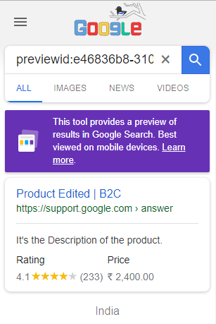

it's an example of rich snippet card in google

| **@type** | **Product** |
| --- | --- |
| **image** | [/b2c-static-s3-bucket.aws.com/products/22be20b1bf2190a3ecccc3dea69d7ae3.jpg](https://search.google.com/structured-data/testing-tool/apies/products/uploads/22be20b1bf2190a3ecccc3dea69d7ae3.jpg) |
| **productID** | 25c84c7af1 |
| **name** | Product Name |
| **description** | This is the description of the product which tells that it is amazing product. |
| **offers** |  |
| **@type** | Offer |
| **priceCurrency** | INR |
| **price** | 2400 |
| **aggregateRating** |  |
| **@type** | AggregateRating |
| **ratingValue** | 4.1 |
| **reviewCount** | 23 |
| **review** |  |
| **@type** | Review |
| **description** | This is a Product review |
| **author** |  |
| **@type** | Thing |
| **name** | Kunal Awasthi |
| **review** |  |
| **@type** | Review |
| **description** | This is an another review |
| **author** |  |
| **@type** | Thing |
| **name** | Test User |

**Cloud Architecture of App**

[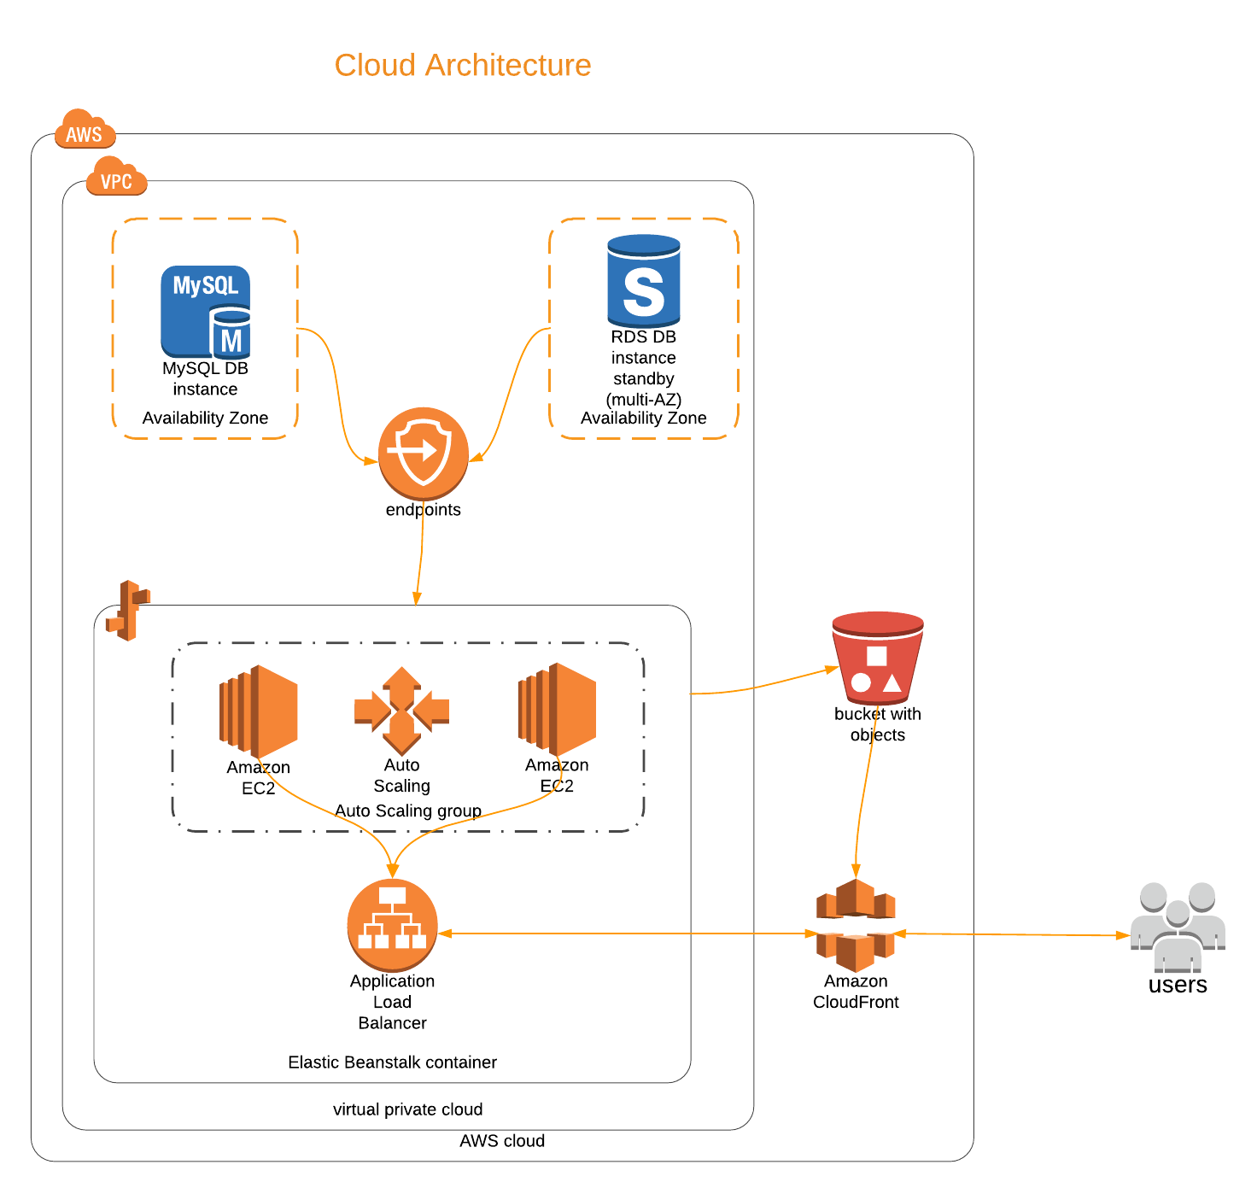](https://www.lucidchart.com/documents/edit/b1104d1e-83c9-41d0-addf-400922e262af/0?callback=close&name=docs&callback_type=back&v=1170&s=736)

Why Cloud ?

* Coz It’s Flexible as it can scale up or down based on traffic
* Software gets updated automatically
* It’s Secure and easy to manage
* Supports work from anywhere and helps teams work together Collaboratively
* And most importantly it’s cost effective and environment friendly.

Having a good cloud architecture of App is crucial to provide the seamless users experience. Because it’s fact that if a page takes more then 3 seconds to load user might probably leave and go to competitors website and would never come to site again and will share his bad experiences with others.

## Cloud Computing Basics -

**Whether you are running applications that share photos to millions of mobile users or you’re supporting the critical operations of your business, a cloud services platform provides rapid access to flexible and low cost IT resources. With cloud computing, you don’t need to make large upfront investments in hardware and spend a lot of time on the heavy lifting of managing that hardware. Instead, you can provision exactly the right type and size of computing resources you need to power your newest bright idea or operate your IT department. You can access as many resources as you need, almost instantly, and only pay for what you use.**

## How Does Cloud Computing Work?

**Cloud computing provides a simple way to access servers, storage, databases and a broad set of application services over the Internet. A Cloud services platform such as Amazon Web Services owns and maintains the network-connected hardware required for these application services, while you provision and use what you need via a web application.**

**Cloud Components used in APP**

**RDS** - Relational database service MySQL

RDS is managed service from AWS. It supports -

* Automated snapshots of database
* Restore to a point of time
* Automatic Software updates are applied

All these services void the need of a DBA

RDS have Endpoint (Hostname) URL so that Database could be accessed from multiple virtual machines running the App.

If we keep Database alongs with the Virtual machine where the App is running then there could be problem if that virtual machine fails or in case where we have multiple virtual machines serving the App.

Simple Storage Service (S3)

S3 is used to Store Static content of App like Images and Videos.

Why use S3 to store static content??

It’s an object Storage. It’s specially designed to quickly upload or retrieve static content from it.

If we keep Static content on Application server then application size would increase.

Lots of Network Bandwidth processing power and memory of Web Server would be consumed in serving static data.

It’s always good practice to keep static contents separate from the main Application.

As in some cases if application scales up and when it have multiple Servers serving the application then it’s not possible to store data on one machine or to replicate to all of them.

S3 can be used to store and retrieve any amount of data at any time.

And it’s also cheap and superfast.

Application could be ported easily to other cloud platforms easily if static content is separate.

EC2 (Elastic Cloud Compute)

It provides scalable computing capacity in simple words it’s a virtual machine.

In this App it’s running LAMP stack on the top of Amazon Linux. It’s the web server which contains all the Application code including API files which transject with database

Load Balancer (ELB)

Load Balancer automatically distributes incoming application traffic across multiple

virtual machines(EC2).

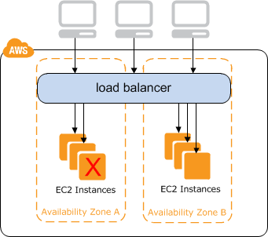

If one EC2 fails it automatically launches the new one while the second one keep serving. So that zero downtime for users.

The main advantage of ELB is it supports auto scaling functionality.

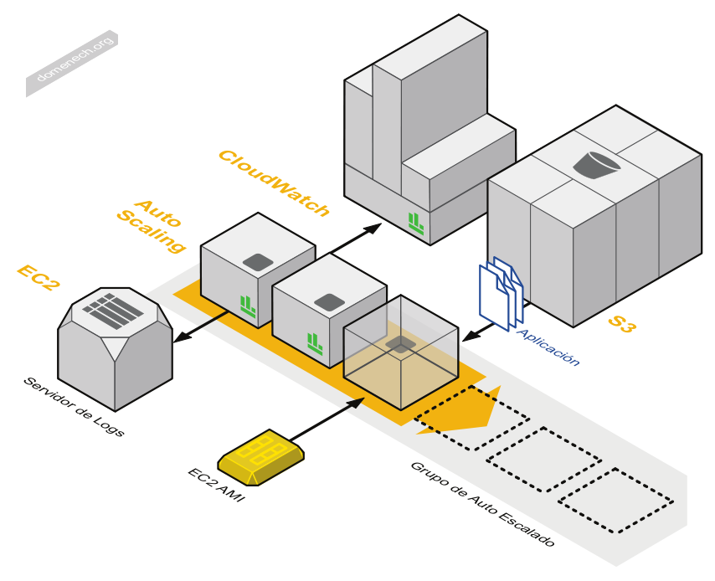

If CPU utilization goes above 75% or Memory uses exceeds 80% a new EC2 instance (Virtual Machine) gets launched automatically.

Vise versa if CPU utilization is below 35% the additional EC2 instance gets terminated automatically to save the cost.

It’s how ELB allocate additional resources when needed for say in festival season when site gets lots of visitors and Deallocate them when traffic is down. Thus making Application cost effective and zero downtime or low latency for users.

**AWS Cloudfront**

It’s a global CDN (content distribution network) service.

It keeps the copy of application data on various regions. There are lots of data centers all over the world. It serves from the nearest server from client.

If a client is requesting the app from jaipur the request is served from Mumbai servers. And if client is from Brazil the request is served from Sao Paulo Servers.

**Serving Compressed Files -** CloudFront automatically compress content for web requests that include Accept-Encoding: gzip in the request header. Files are compressed and delivered so page load becomes faster.

**Minifying CSS and JS files** - **Minification** refers to the process of removing unnecessary or redundant data without affecting how the resource is processed by the browser.

* In development environment plain CSS and JS should be used.
* And in production it’s good idea to minify.

It reduces the size of CSS and JS files so that they could be delivered faster and unnecessary spaces are removed so it becomes non-human readable. It’s an advantage as anyone can’t simply steal our Design or JS code and reuse it.

**Monitoring with Cloudfront**

With the help of cloudfront we can get lots of data about the visitors. Like -

* Number of requests everyday
* Minimum, Maximum and Average requests in a month
* Data transferred everyday
* And their monthly min, max and Avg amount
* Data transferred by Destination

This show the amount of data transferred from cloudfront to origin(Virtual servers) and from cloudfront to Users

This data helps us monitor the efficiency of Cloudfront caching system.

**List of Top Referrers** - Referrers tells that from which origin users are reaching to our site.

This helps us monitor how users are getting to our App.

We can monitor how much users are getting to our site from Google search results or from Bing or Yahoo. As well as how much are visiting by entering URL in address bar.

We can get the request count and the percent of requests for each referrer.

**User monitoring with Cloudfront -** We can monitor the percent of requests from a specific device type, browser, operating system and location

**Devices** - We get a chart which shows the percentage of requests that CloudFront received from the most popular types of device. Valid values include:

* Desktop
* Mobile (either a tablet or a phone)
* Tablet
* TV
* Bot/Crawler: primarily requests from search engines that are indexing your content
* Unknown: requests for which the value of the User-Agent HTTP header was not associated with one of the standard device types, for example, Desktop or Mobile
* Empty: requests for which the value of the User-Agent HTTP header was empty

We can view these results in the form of pie charts so we can understand the users.

**Browsers** - chart shows the percentage of requests that CloudFront received from most popular types of browser, either by name (Chrome, Firefox, Internet Explorer, and so on) or by name and version. Other valid values include the following:

* Bot/Crawler: primarily requests from search engines that are indexing your content
* Unknown: requests for which the value of the User-Agent HTTP header was not associated with a standard browser. Most requests in this category come from custom applications or scripts.
* Empty: requests for which the value of the User-Agent HTTP header was empty
* Other: browsers that we have identified but that are not among the most popular. If Bot/Crawler, Unknown, and/or Empty do not appear among the first nine values, then they are included in Other, too.

**Operating System** - chart shows the percentage of requests that CloudFront received from most popular types of operating system, either by name (Mac, Linux, and so on) or by name and version. Other valid values include the following:

* Bot/Crawler: primarily requests from search engines that are indexing your content
* Unknown: requests for which the operating system is not specified in the User-Agent header.
* Empty: requests for which the value of the User-Agent HTTP header was empty.
* Other: operating systems that we have identified but that are not among the most popular. If Bot/Crawler, Unknown, and/or Empty do not appear among the first nine values, then they are included in Other, too.

**Locations** - This chart shows the number of requests that CloudFront received from each location over time by country.

**Security -** So we have RDS(database) as an individual instance and multiple EC2s for running App code and S3 to deliver static content which they all are on open Internet. How we can make sure that App and User data is secured?

All the instances are in AWS VPC(Virtual Private Cloud)

Only way to interact or access with App is Cloudfront which filters requests to ensure that only valid HTTP(S) requests will be forwarded to backend hosts.

And it’s also capable of determining and safeguarding the App from DDos attacks.

RDS (database) could be only accessed by EC2s within the VPC.

EC2s (Virtual Machines) are only accessible via Load Balancer.

And the S3 and Load Balancer are only accessible via Cloudfront.

This architecture enables the App to securely function within VPC and makes it capable to handle sudden spikes in traffic while keeping the COST in control.

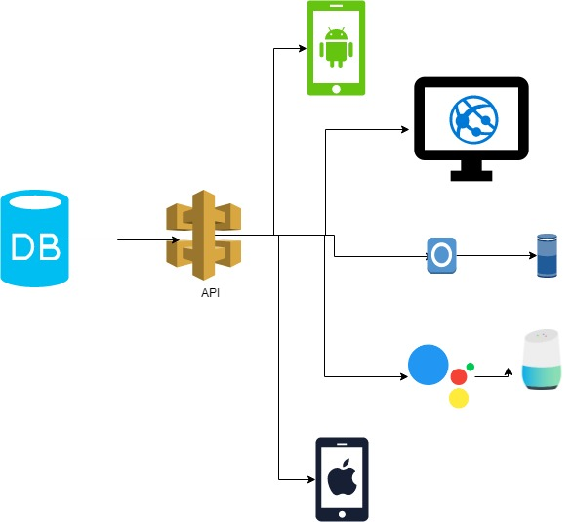

It’s not a website. Website sounds like static kind of…

It’s an Application with web frontend, So technically it’s a Webapp.

Application is designed using REST APIs so more interfaces could be added in future, like - Android & iOS APP,

VB Application, Webapp for Mobile & Desktop

# **6.Feasibility Study**

## Technical Feasibility

#### Client Server Model

Whole Project evolve around Client-Server Model. and to fulfill this requirement there are lots of Service Providers like Amazon AWS(used in Project ),HostGator, MilesWeb that provides Excellent Services like dedicated servers & cloud platform. So while choosing the Server provider we need to keep in mind that in servers are fast performing, scalable and cost effective also. We decided to choose AWS because they provide large catalog of services at reliable prices.

#### PHP(HyperText Preprocessor or Perl Home Page)

General Purpose Programming language to modal data and save it to a data storage Project used PHP Programming language that is a OPEN Source Language and its community support is also very wide.

#### Data Management (MySQL & PHP PDO)

In data management we have two major options here to choose from -

Relational database and NoSQL database.

As relational databases are well known for their capability for handling transactional data and they are well tested and proven tech and even we are more familiar with SQL rather then NoSQL so it’s safe to choose RDS MySQL.

MySQL is a relational database manager which is free and highly compatible with PHP. It will be used to store data relating to many aspects of operation. PHP provide PDO Library and MySQLi Library for MySQL database connectivity.

#### Client Side Scripting Language (JavaScript & JQuery)

JavaScript, often abbreviated as JS, is a high-level, interpreted programming language. It is a language which is also characterized as dynamic, weakly typed, prototype-based and multi-paradigm. jQuery is framework of JavaScript, That Provides some ease to write front-end code like ajax calls, UI Modifications and also fast and reliable. Both Provides a platform to provide interactive UI & Web experience to end user.

**Data transmission**

For transmission of data between server and client side without reloading the web page or to get data dynamically there are couple of options here -

JSON and XML

**JSON (JavaScript Object Notation) is a lightweight format that is used for data interchanging.**It is based on a subset of JavaScript language

## Behavioural Feasibility

#### User Adaptation

E-Commerce is already on hype, coupling globalization and internet it brings many possibilities and Opportunity for Resellers to target More and More audience through it. People started using e-commerce platform to buy essential products and daily need. and with easy payment systems and money transfers it is more faster than going to a store then standing in long queues.

#### Time, Effort, Resources

Mainly Virtual Stores are created to save time & Effort. It is like on the go where a Customer can Compare many products with different retailers, different-different Prices effectively it saves Time, Effort and Resources Like Money and transportation costs also.

If we consider Retailer/Merchant’s Costs it also save resources like Real Store, big inventories (on demand vending), Time Saving because all accounting is at Technology end.

So, Both Customer and Merchant (Both End Users) have cost cutting advantages in shopping and retailing ecosystem.

## Economic Feasibility

#### Costs and benefits

this Project Costs Servers ( Cloud Services ), Programmers. Programming languages, Development Tools are open source that were/are developed by community and its core developing team. so project cost resides mainly on mainframes cloud platform and developing team. As we talk about Benefits first of all it consists a new ecosystem for small vendors, merchants who really need wider audience to excel themselves. for Project Developers benefits are less Accounting overheads, less paperwork. only focus goes on the customer and end user satisfaction.

7. Data Flow Diagrams

**1. Context Level Diagram**

[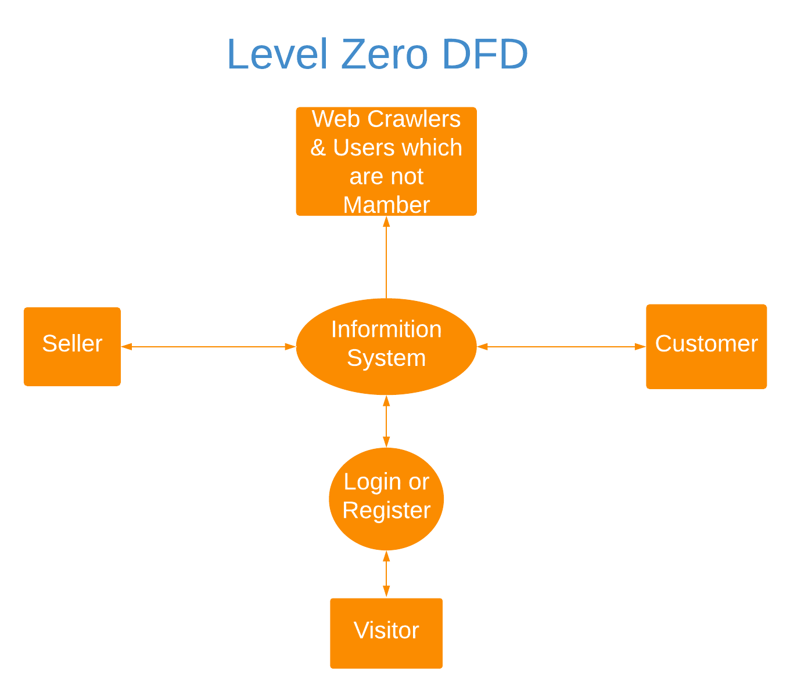](https://www.lucidchart.com/documents/edit/4c0ff9bc-2aa6-4a3a-9ba0-866323d9f0da/0?callback=close&name=docs&callback_type=back&v=4487&s=680)

**2. Level 1 Diagram**

[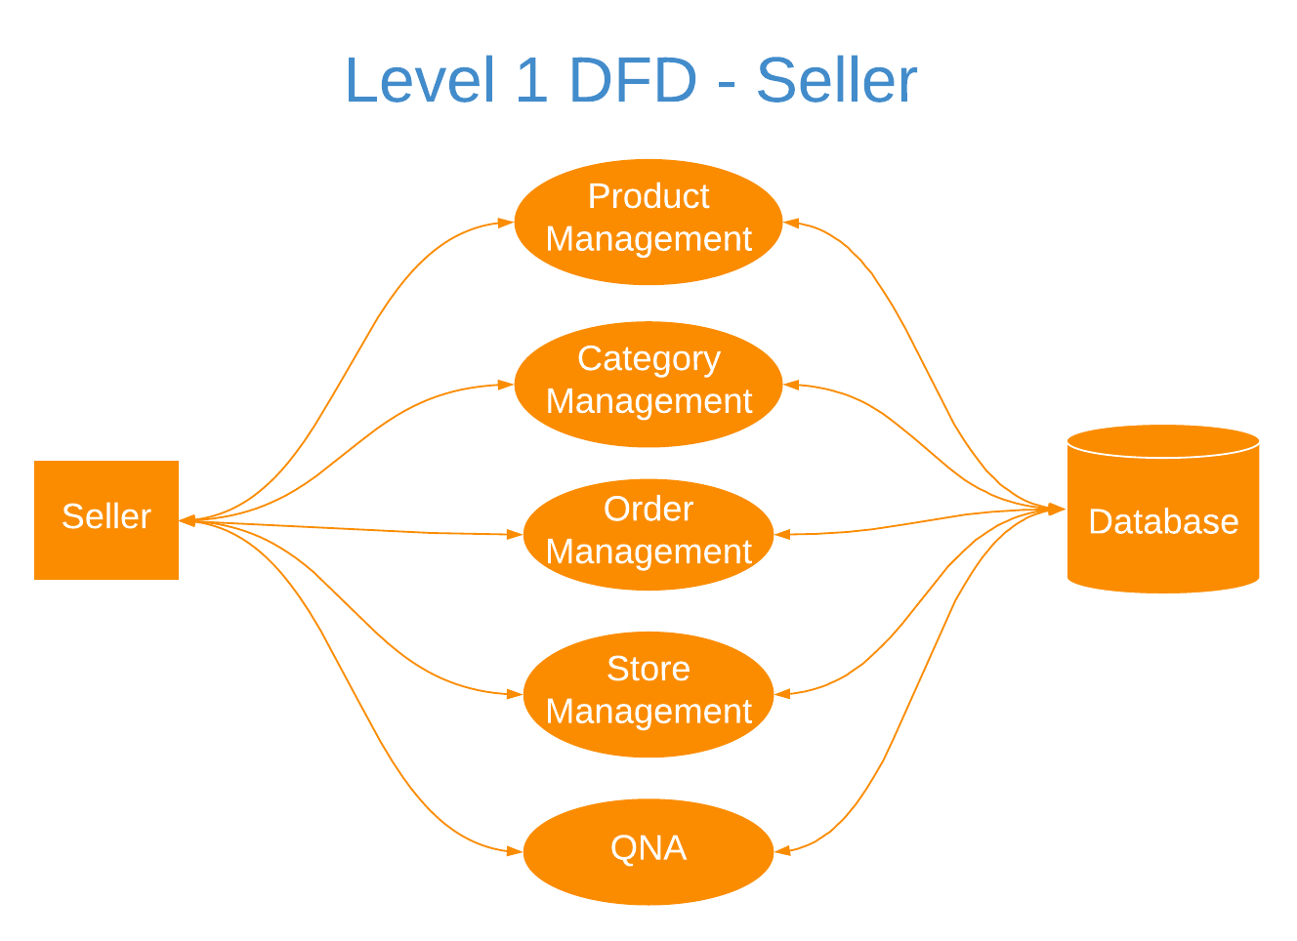](https://www.lucidchart.com/documents/edit/1ccf972b-b298-4a72-ae0d-b830347d7539/0?callback=close&name=docs&callback_type=back&v=137&s=664)[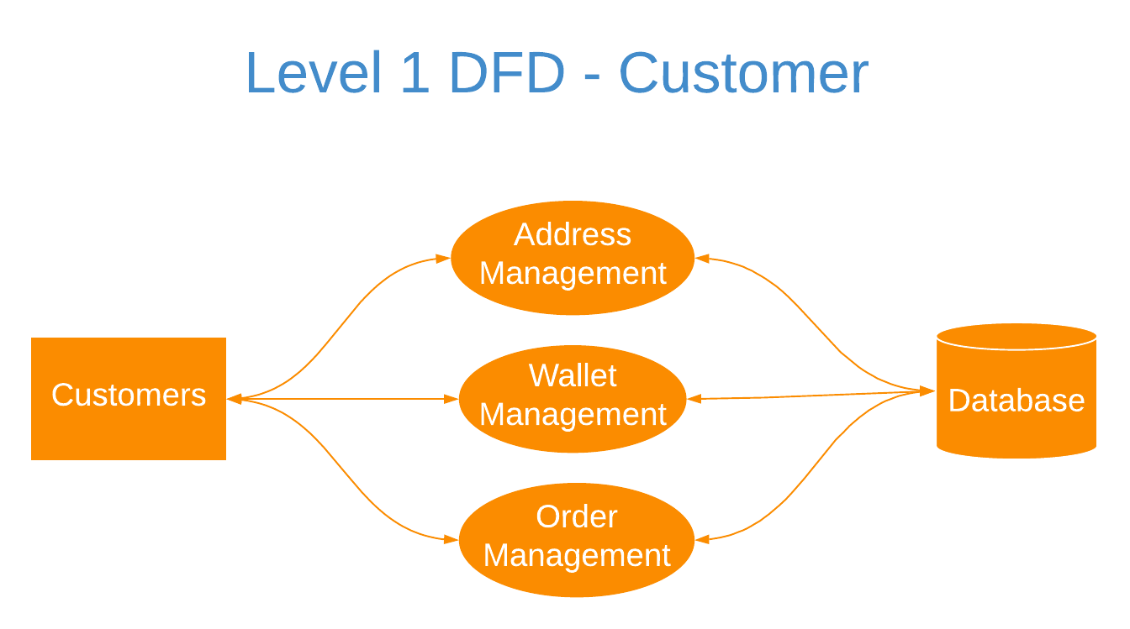](https://www.lucidchart.com/documents/edit/2518b268-139b-4978-86bc-63a38c81d52a/0?callback=close&name=docs&callback_type=back&v=119&s=672)

**3. Level 2 Diagram**

[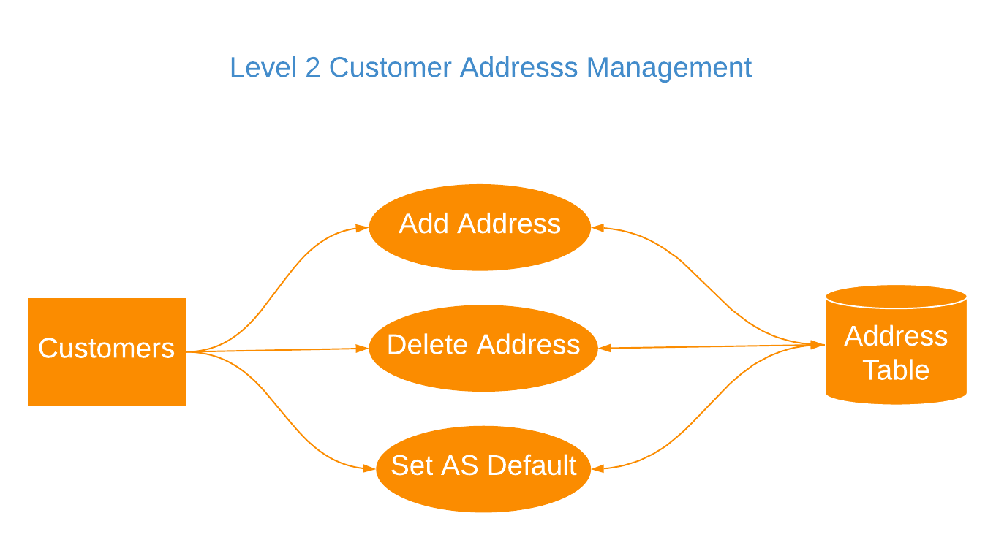](https://www.lucidchart.com/documents/edit/cc23c699-e366-45fc-a5f9-53af8afd18a3/0?callback=close&name=docs&callback_type=back&v=122&s=681)

[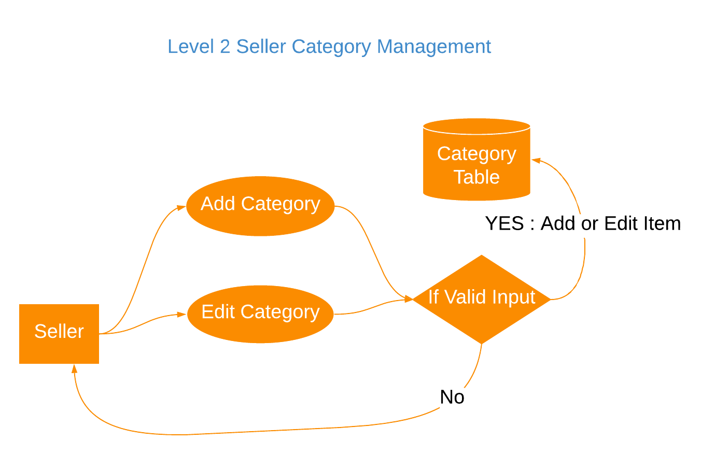](https://www.lucidchart.com/documents/edit/6cebb6ce-be28-4aa9-ab3a-574ff83e573f/0?callback=close&name=docs&callback_type=back&v=135&s=676)

[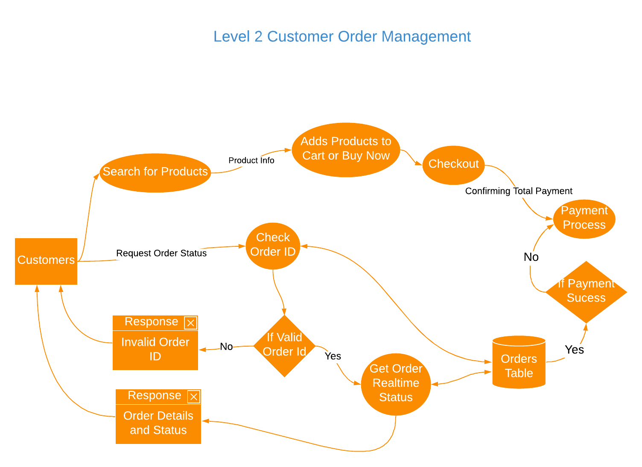](https://www.lucidchart.com/documents/edit/bb5cd138-5188-4361-be76-a77fbbabb7b0/0?callback=close&name=docs&callback_type=back&v=153&s=752)

[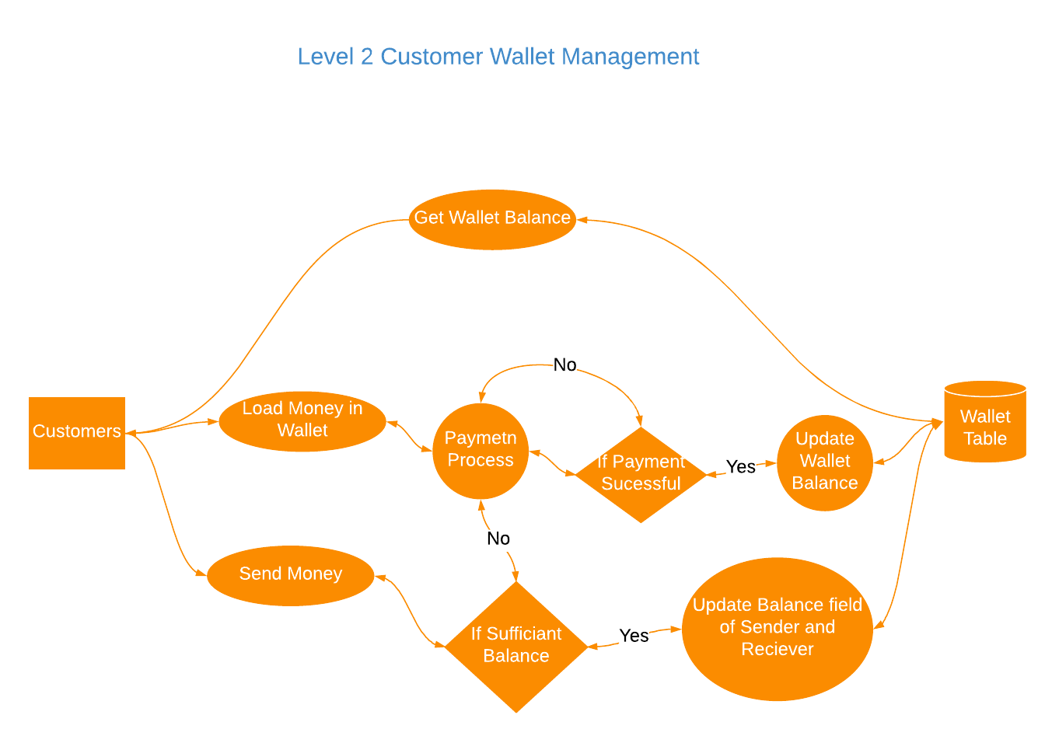](https://www.lucidchart.com/documents/edit/34e6a0f2-bea6-4dcb-8b2a-9a90fd3e5e57/0?callback=close&name=docs&callback_type=back&v=134&s=672)

[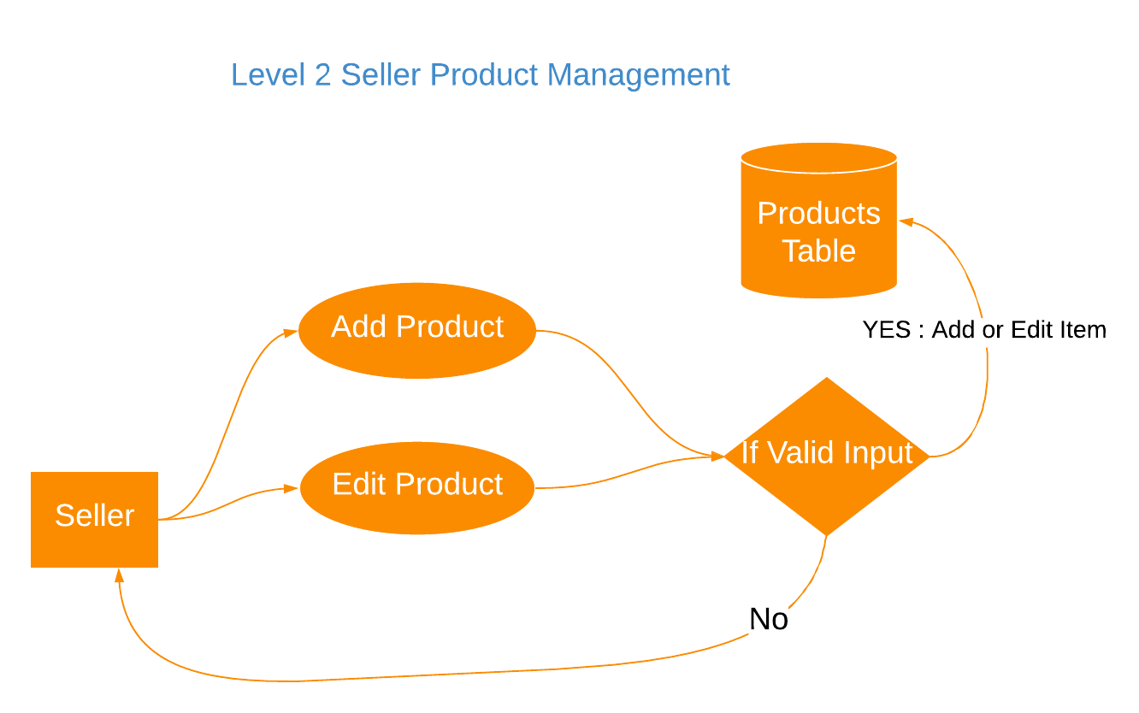](https://www.lucidchart.com/documents/edit/a119bfd6-566a-42db-9ef3-d56c8e76dae1/0?callback=close&name=docs&callback_type=back&v=128&s=666)[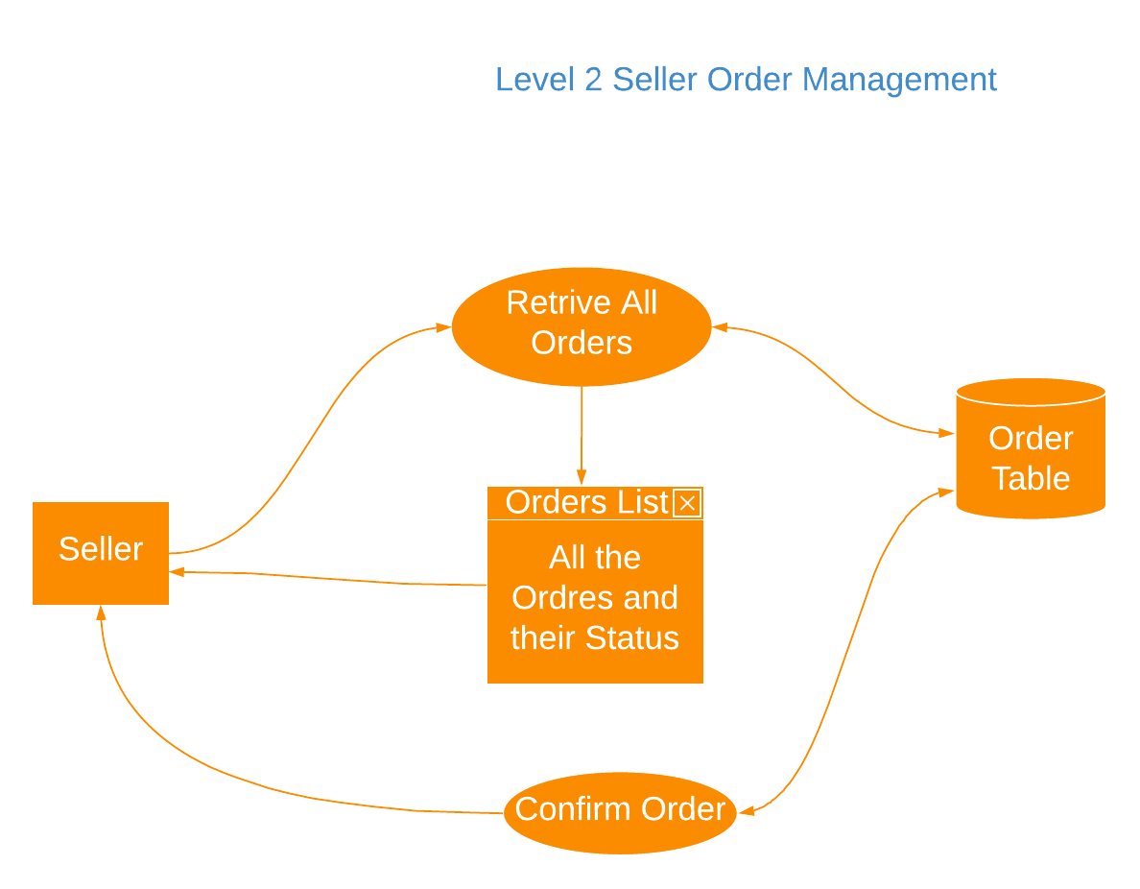](https://www.lucidchart.com/documents/edit/288e8a5c-6e3e-418a-a661-218e5f7b7158/0?callback=close&name=docs&callback_type=back&v=107&s=594)

[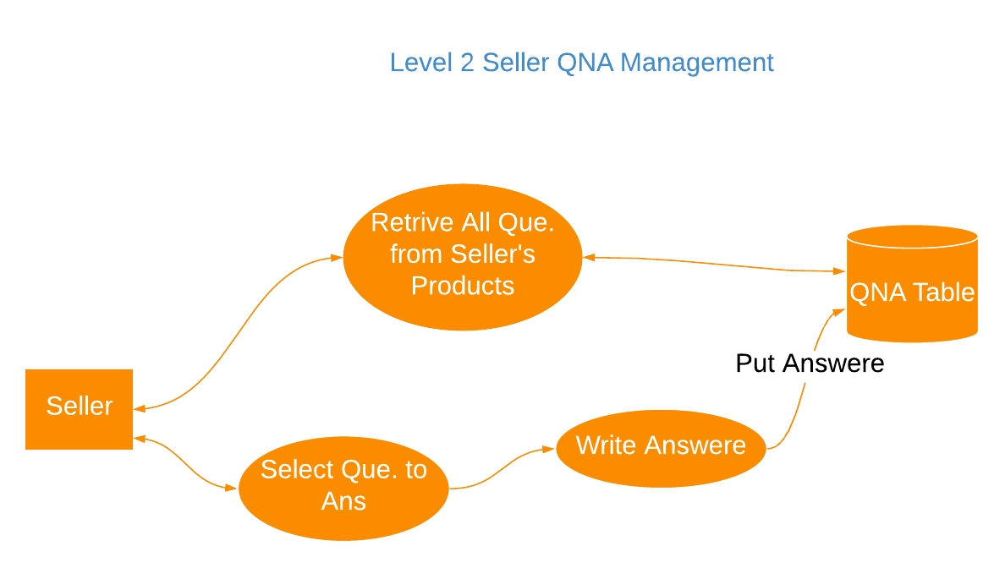](https://www.lucidchart.com/documents/edit/0a4eb499-d5d4-4429-9704-371b246dd372/0?callback=close&name=docs&callback_type=back&v=117&s=594)

[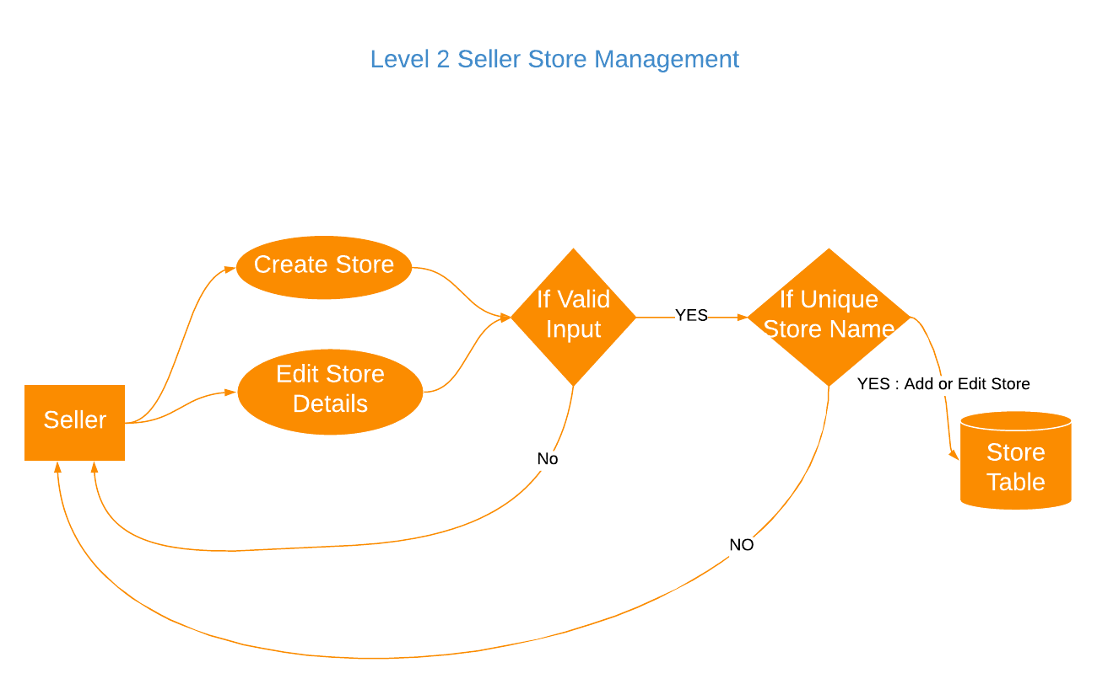](https://www.lucidchart.com/documents/edit/adac81b7-d256-4c2e-8308-5d59aa0e69c2/0?callback=close&name=docs&callback_type=back&v=143&s=650)

[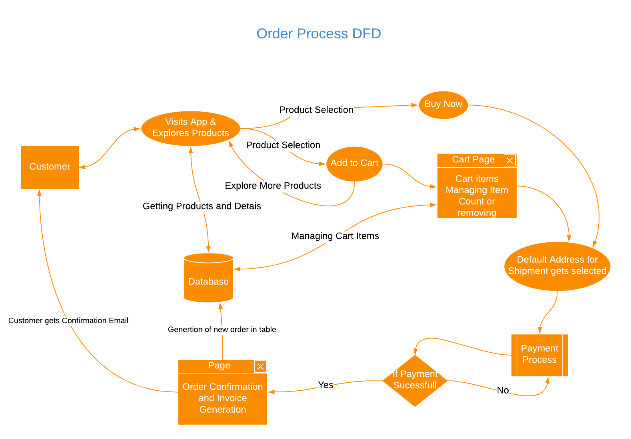](https://www.lucidchart.com/documents/edit/80786b32-629f-47aa-9a21-cb2aa619ae2c/0?callback=close&name=docs&callback_type=back&v=136&s=789)

[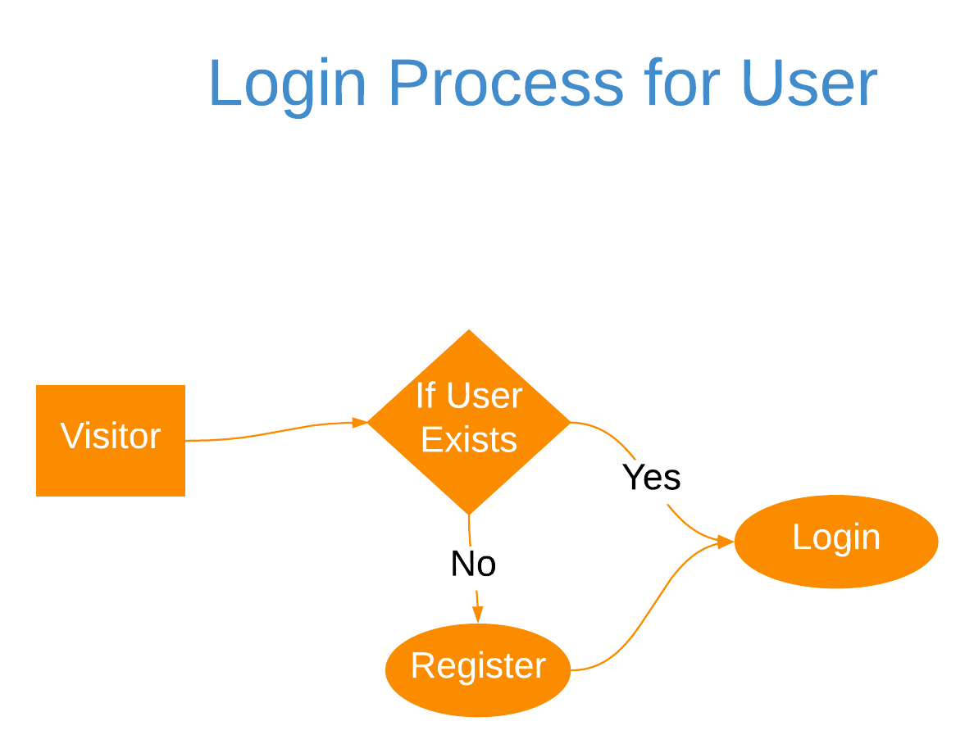](https://www.lucidchart.com/documents/edit/f40aef0c-5e6c-4e88-b212-616bb2a5e1d1/0?callback=close&name=docs&callback_type=back&v=103&s=594)

# 8. E R Diagram and Database Tables

[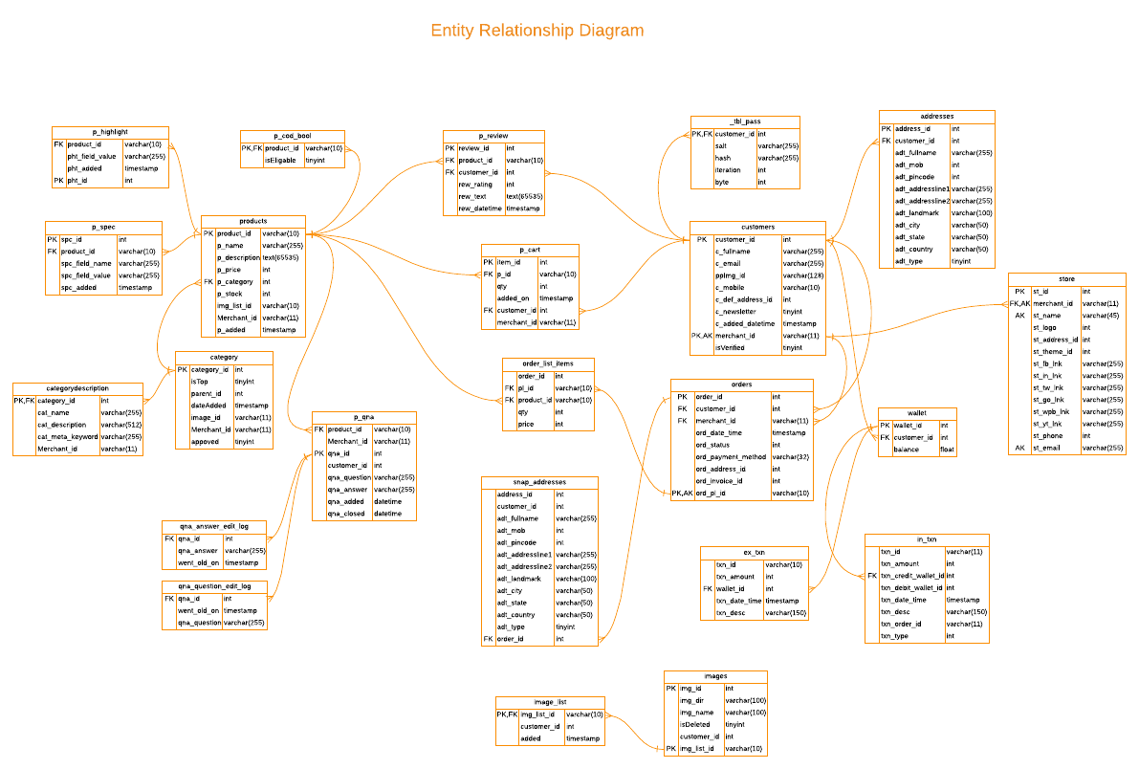](https://www.lucidchart.com/documents/edit/41887a9d-449c-4ede-9080-de49469b80f5/0?callback=close&name=docs&callback_type=back&v=9866&s=595.35)

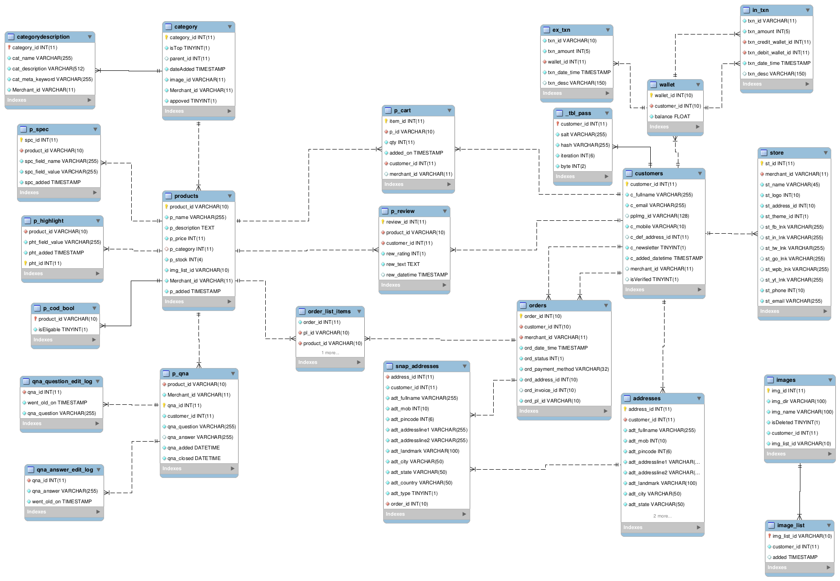

# 9. Project Design (Screenshots)



Header- The header is the top rectangular shaped area that runs across the top of the web page design on your screen. Unless you are wanting to be unusual and trying to step completely ‘outside the box’, it will appear on every web page.

On header there is option of shop by categories in which one can directly search the products they want . All the categories will be shown differently so this will not consume the time of buyers.



Footer - The bottom section of a webpage is also known as a footer. This area typically contains the name of the company or organization that publishes the website, along with relevant copyright information. Some websites may also include basic navigation links, such as "About Us," "Contact," and "Help." Corporate website footers often include additional links to "Terms of Use," "Privacy Guidelines," and "Advertising" pages as well.

There are many options in footer ex- contact with us on which one can directly contact the dealer through Facebook, Instagram or whatsapp.

Instead of this ,one who wants to sale their products can also start doing by using tha option start selling and make money.

The last option is quick link in which you will get the details of the developers and their complete information.

**Login Page -**

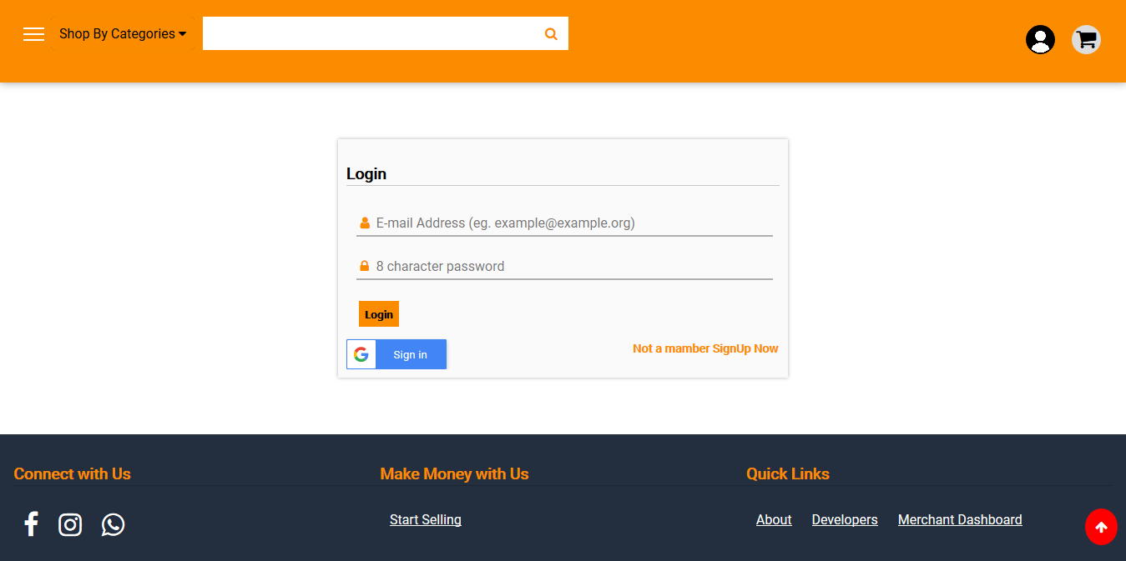

Loggin page- Login is the entering of identifier information into a system by a user in order to access that system in a website. A login generally required the user to enter two pieces of information.

(1) a user name

(2) a password

A user name , also referred to as ab account name that uniquely identifies a user. User name can be the same as or related to the real names of users, or they can be completely arbitrary.

A password is likewise a string, but it differs from a user namein that it isintended to be keptis known only to its user and perhaps to the system administrator. After filling this information you have to click on login option and you will enter in the website home page.

**Signup Page -**

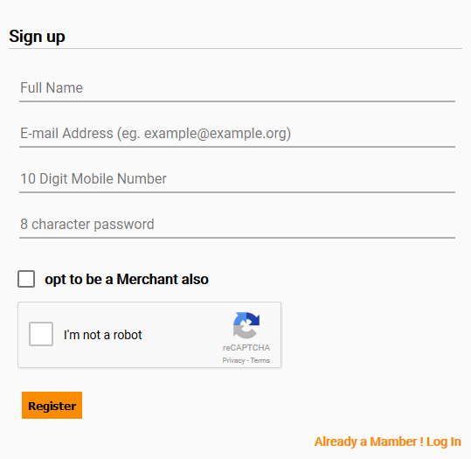

**Merchant Dashboard -**

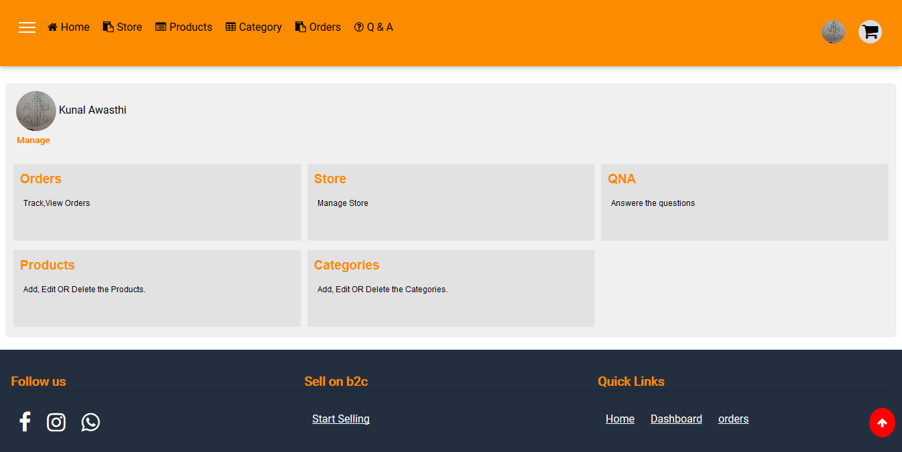

All in one place to manage merchant activities like Orders Store Products and Categories

**Orders Management -**

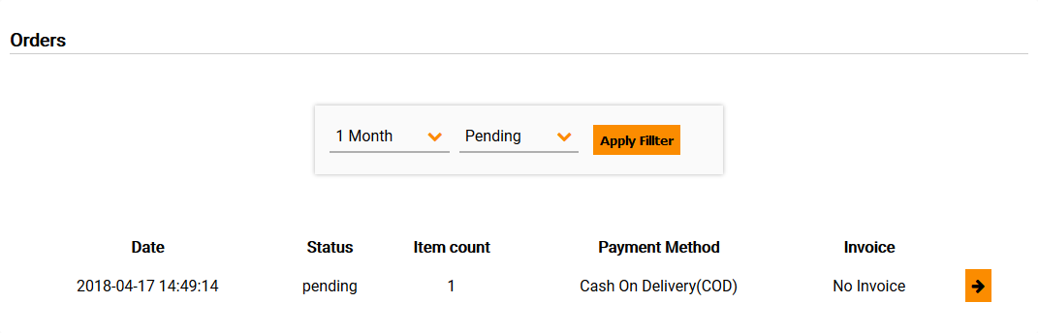

This page lists all the orders merchant has got from the customers. The list includes date time when the order was placed, order statu, item count and payment method for that particular order.

**Store Management -**

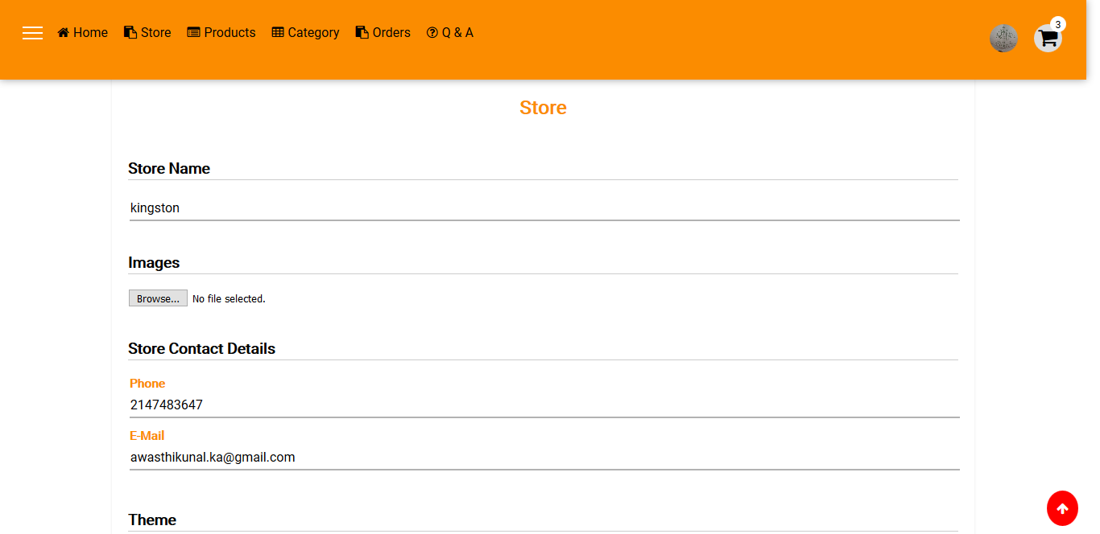

Merchants can set up their Own separate Store. This from lets merchants define store details like contact info, social media links name etc.

Merchants can host their store on their own domain and by default they get a url from where store can be accessed.

**Add new Product page -**



This page allows merchants to add new products to Platform which will appear both on common e-Marketplace as well as on their individual stores.

Merchants define the category to which product belongs to, provides description, name, price and availability in stock and various product specifications.

For now this page also lists already added products.

**Category Management page -**

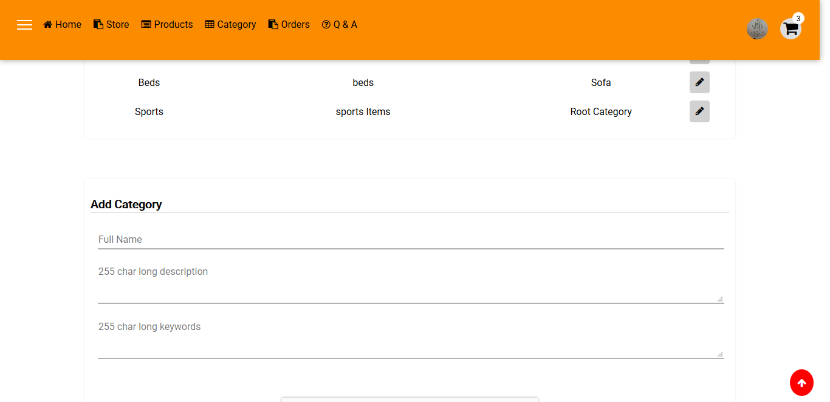

This page allows merchants to manage their categories like merchants can add new category if they are adding a product and the category doesn’t exist, new category can be added. It also lists the categories which are added by merchant prior.

**Browse products by Categories -**

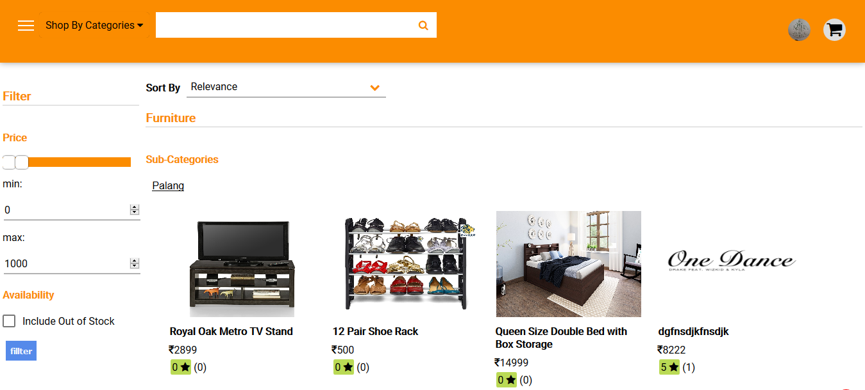

Customers can browse products through various available categories. Filters and sorting can be applied. For example a customer is looking products within a price range Or sort products by prices low to high.

**The product page -**

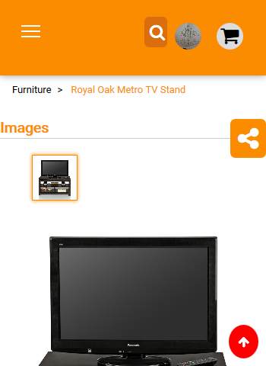 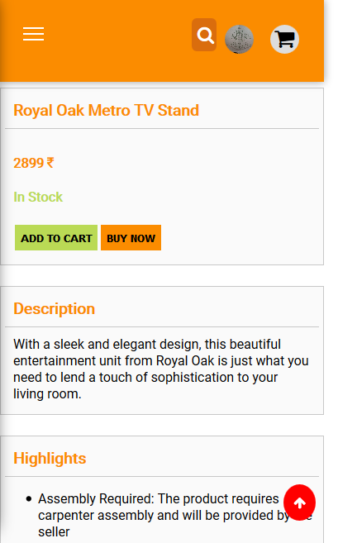

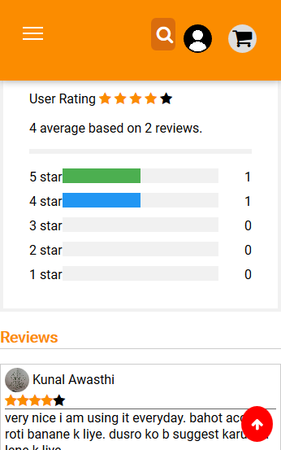 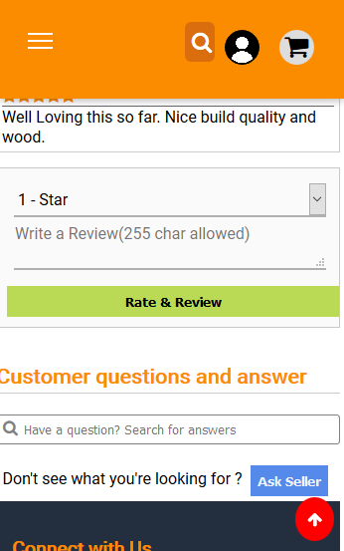

Pages are mobile optimized so they do looks good even on mobile devices.

Product page contains all the information about the product like name, price, description, some key highlights and reviews and rating from other customers as well.

And finally if customers have any doubt regarding the product they can simply ask question to seller.

Product page contains a breadcrumb for the nested categories to which product belongs to.

**Product Share Button -**

product page have a share button which can be used to share that particular products with others. It makes project even pretty useful when someone not want to sell online. So this can be helpful in product catalog management. Like when someone asks to merchant for photos of their products they don’t need to look them up in gallery, link of the product can be easily shared via SMS, whatsapp, Email or twitter. These share buttons are written specially so it’s not link you have to copy link manually and paste in whatsapp chat, thus sharing of products becomes easier.

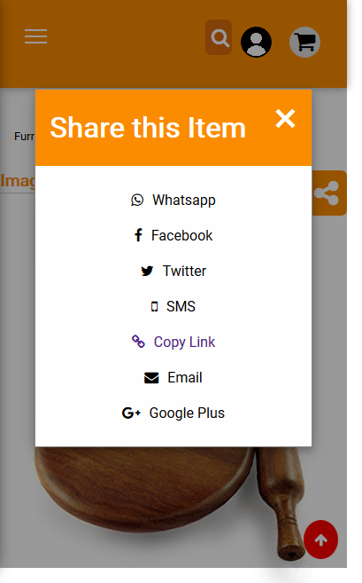

[share page]

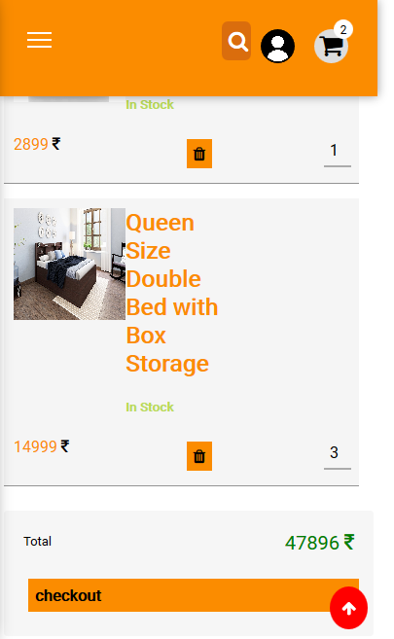

[cart page]

**Cart Page-** After adding products to cart, on cart page customer get the list of all the products along with their images and name in the cart with their count which they can change and a final estimated price is calculated.

**Payment page -**

On payment page if customer have money in his/her wallet they get an option to use that money, and if balance is not sufficient for that order payment gets splitted. In which available wallet money is used and rest amount is collected via payment gateway.

On successful payment customer is redirected to orders list where it can view details for orders.

The functionality to handle failed payment is not implemented yet.

*for now payment gateway is not working.* Only the UI has implemented.

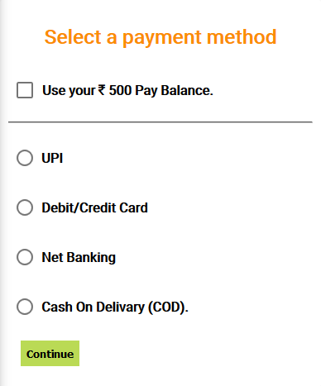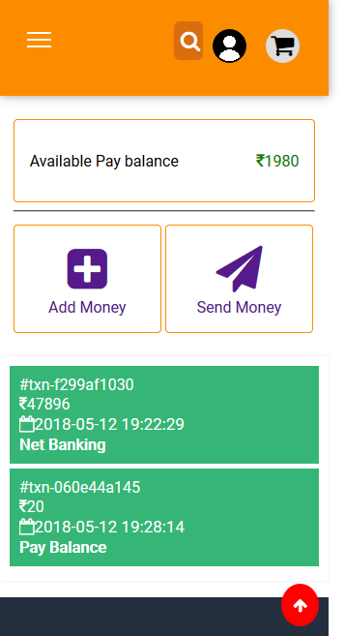

**Customer Wallet -**

* It shows available current balance.
* Customer can send money to another customers by putting creditor’s phone number and amount.
* Lists all the transactions by customer with their date time, amount, transaction ID and Payment method used in that transaction

**Customer Address Management -**

* List all addresses
* Add new address
* Set an address as default which will be used in all next orders
* Delete an address

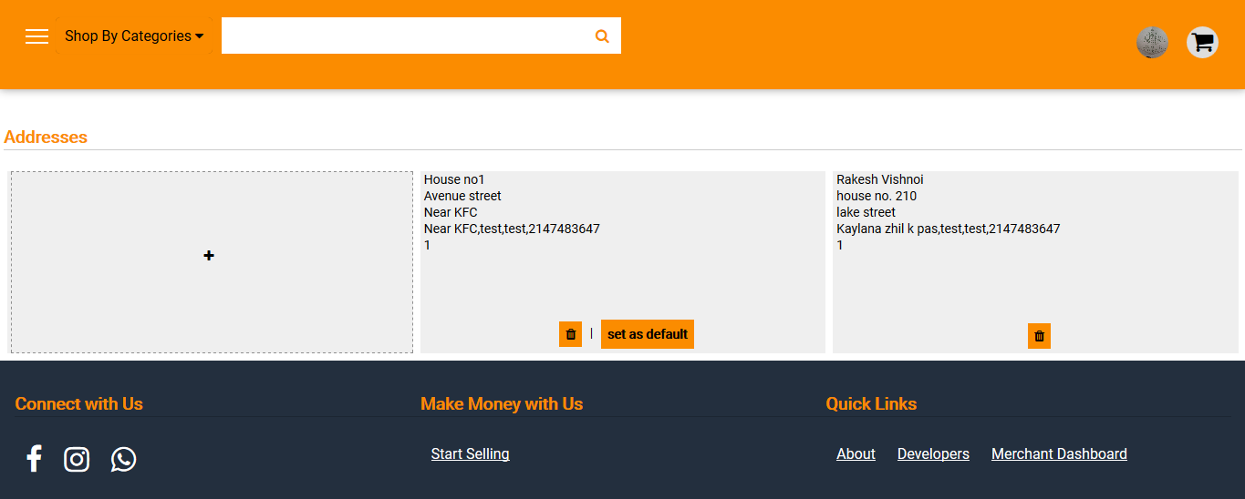

**Search suggestions -**

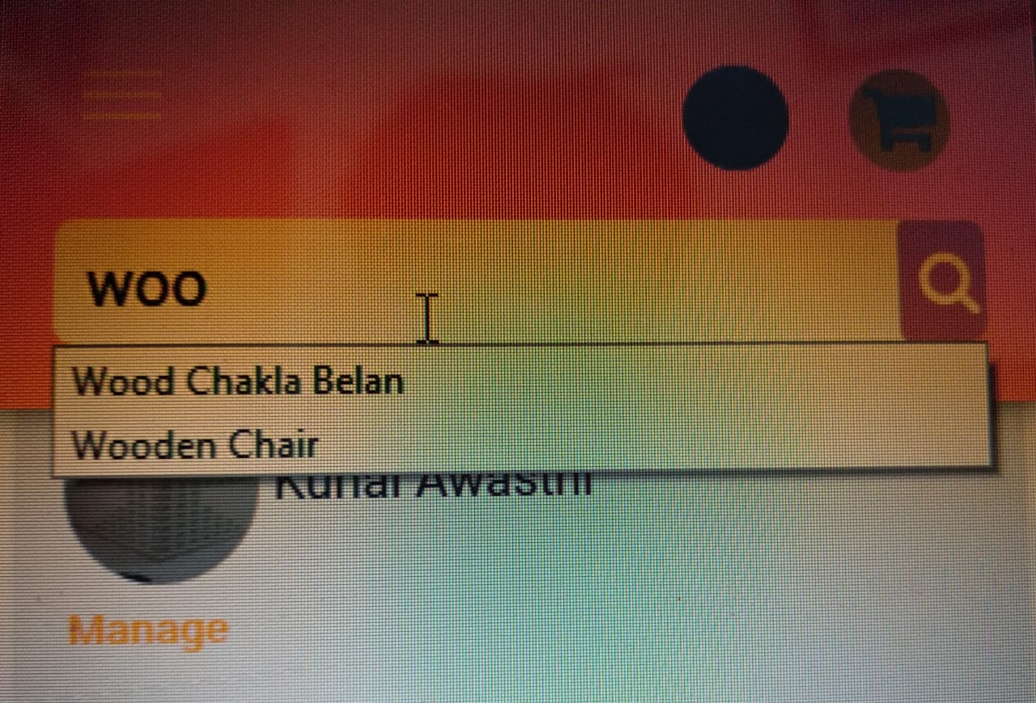

when something is typed into search bar related product names appear as reference.

Though the search functionality has not implemented.

**Custom Store -**

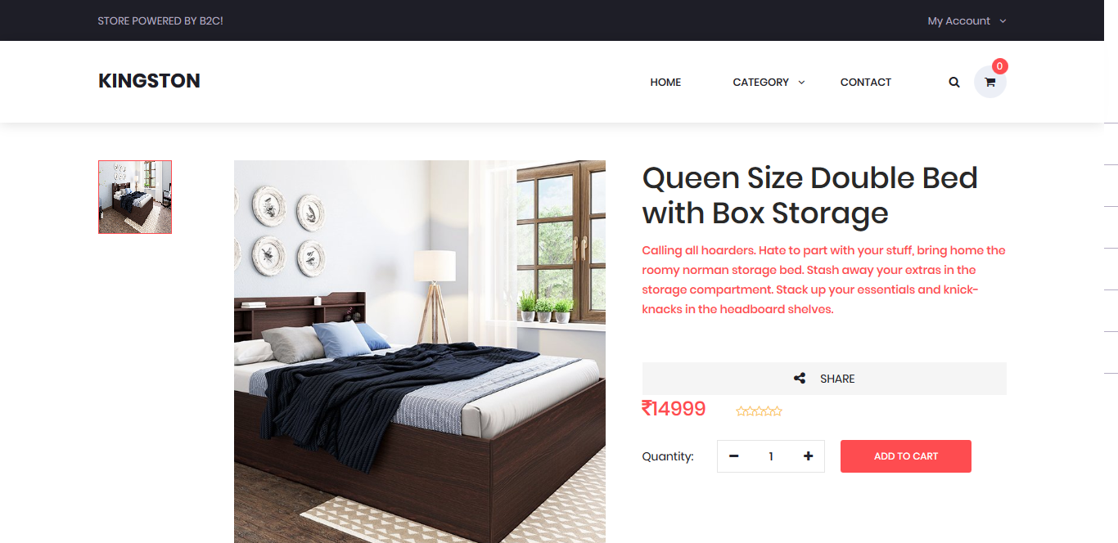

**Store Contact page -**

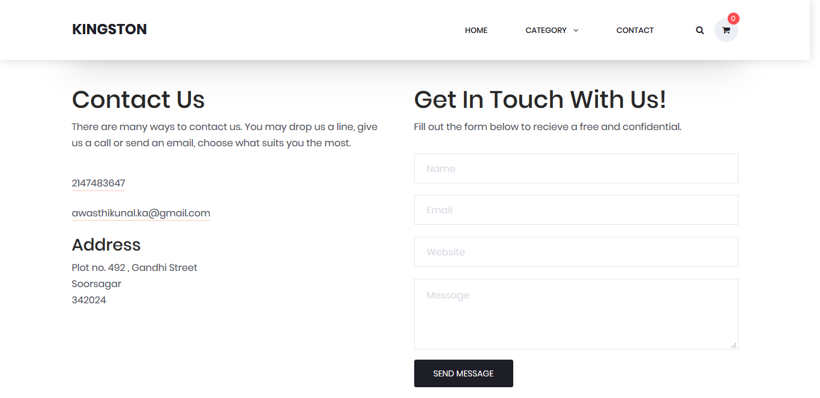

# 10. Future Enhancements

**Problem with Developed system -**  The developed systems right now have challenges of product transportation. An example of problematic scenario is there’s a merchant which import products from jaipur and store them in warehouse and delivery to customers on orders. And then a customer orders from that merchant then product price will be costly because of increased transportation charges. Product was manufactured in jaipur and transported to jodhpur for warehouse storage and again gets transported to jaipur for customer delivery.

In order to make this project physiable in real world it needs to find the nearest merchants providing that product to the customer.

**Finding nearest merchants with Geolocation -**

Google maps API can be used to measure the distance between two geo coordinates.

An existing example of system is book my show. They detect customer’s location with GPS and show the movies and events running in that city.

Similarly this project can be extended so it will stores GPS coordinates for both merchants and customers. So when someone will search for a product, it’ll show the products from nearest merchants to their location to decrease transportation charges.

# 11. Conclusion

In general, today’s businesses must always strive to create the next best thing that consumers will want because consumers continue to desire their products, services etc. to continuously be better, faster, and cheaper. In this world of new technology, businesses need to accommodate to the new types of consumer needs and trends because it will prove to be vital to their business’ success and survival. E-commerce is continuously progressing and is becoming more and more important to businesses as technology continues to advance and is something that should be taken advantage of and implemented.

From the inception of the Internet and e-commerce, the possibilities have become endless for both businesses and consumers. Creating more opportunities for profit and advancements for businesses, while creating more options for consumers. However, just like anything else, e-commerce has its disadvantages including consumer uncertainties, but nothing that can not be resolved or avoided by good decision-making and business practices.

There are several factors and variables that need to be considered and decided upon when starting an e-commerce business. Some of these include: types of e-commerce, marketing strategies, and countless more. If the correct methods and practices are followed, a business will prosper in an e-commerce setting with much success and profitability.

# 12. References

Stack Overflow - <https://stackoverflow.com/>

Google - <https://www.google.co.in>

Wikipedia - <https://www.wikipedia.org/>

AWS Documentation - <https://aws.amazon.com/documentation/>

PHP Documentation - <http://www.php.net/>

MySql and MySql Workbench Tools - <https://dev.mysql.com/doc/>

Quora - <https://www.quora.com/>

w3 School - <https://www.w3schools.com>

Javascript Developer Community - <https://developer.mozilla.org/bm/docs/Web/JavaScript/Reference>

Books

1. I.Sommerville, “Software Engineering”, Addison Wesley
2. System Analysis and Design, Elias M Awad
3. PHP complete reference , Steven holzner
4. Javascript The Definitive Guide, By David langan
5. Head First SQL: Your Brain on SQL -- A Learner's Guide

# 13. Appendix

#### Indian Ecommerce Market

Retail eCommerce sales in India are looking up like never before – presenting a shining and rosy picture.

The retail sale over eCommerce portals in the country touched an unprecedented high of $5.30 billion during CY 2014 , media and commerce, also expect it to grow by 45.2% over 2015 and touch a figure of $7.60 billion. Now while that is heartening news and augurs well for the future of online retail in India which is still in the embryonic stage, the fine print beyond this is somewhat disturbing. In spite of the industry having grown by leaps and bounds, **online retails in India accounts for less than 1% of the total retail sales**. And the trend is expected to continue in the future as well as the eCommerce is expected to contribute only 1.4% of the total retail sales even by 2018.

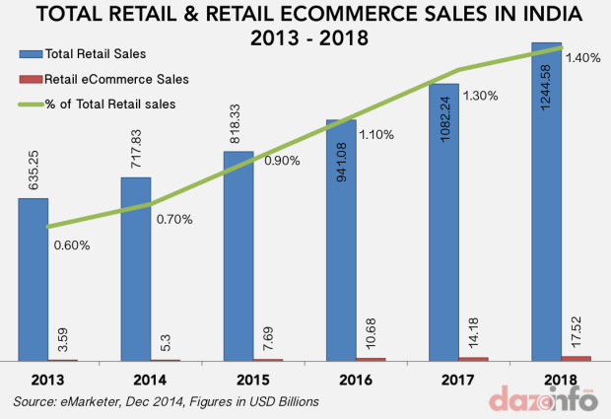

E-commerce is probably the best thing that has happened to the Indian middle-class and emerging small businesses. As a business model, it appeals to the ‘value-minded’ Indian mindset, which is about getting the best value for money spent,” said Nelson D’Souza, general manager, Fundsupermart.com, one of Asia’s largest distributor of mutual funds online. “Around the world, e-commerce has brought in ‘bargain hunting’, which is common to middle- classes around the world.

**Government policy:** One of the main factors holding back an otherwise robust growth is the government restriction on FDI. As per the existing policy, FDI is not allowed in B2C segment though B2B segment can invite foreign investors too. As a result of this crippling policy, overseas players in India have to operate along the marketplace model which not only reduces their profit margins but also gives them little control of products or services being offered and their delivery. This sector, which requires huge amount of liquid capital and experimentation before online sellers can adopt a model which works best for them, is hugely restricted by this handicap.

**CoD and High Rate Of Return:** The most popular mode of payment for online purchases in India is Cash on Delivery (COD). This affects the profits of the online retailers in two ways- the courier service charges extra for making a CoD delivery. In addition to that, the rate of return which is higher in this mode of payment ultimately translates into higher costs and longer credit cycles.

**Touch and Feel Factor:** The mindset of the people in the country has not changed with the times. A majority of buyers prefer to touch and feel the goods before they buy them. That also explains why travel is one of the best converting segments- the customers do not need to see the tangible good before them before affecting the purchase.

**Cybercrime:** A larger part of our population dreads the prospect of having to pay online. While they are comfortable with NEFT and RTGS transfers, they are reluctant using their debit or credit cards for purchasing online, the reason being cyber crime. That includes criminal activities like phishing, DDoS attacks, viruses, malware, etc. Fear of cyber criminals deters credit card holders (though their percentage is extremely low) from using their cards to purchase online. While most of their fears are unfounded, they cannot be entirely blamed because such cases are not completely unheard of.

**Logistics:** No matter how much we hate to admit it, we have third world logistics. The huge success of online retail in developed countries is largely because of their rock-solid logistics.

As someone who frequently makes online purchases, we personally relate to this person’s woes. The courier delivery guy MUST call up every time before the packet is finally delivered, though the address is easily locatable. The courier companies do not have even bar code readers to scan the items during transit. Compare this with the U.S. where the companies give minute by minute details of the delivery of their package. Though Flipkart has worked hard on that front and we now get regular SMS messages informing us about the progress of our package, we sincerely feel that the major eCommerce players have a long distance to cover before they can give their buyers a WOW level of experience.

**Taxation and profitability :** Apart from that, the tax rates in India vary from sector to sector which is not the case in countries like UK and USA- they have uniform tax rates. This adds to the woes of online sellers. Add to it the fact that the average order value is very low, bringing down their overall profitability.

From the consumer’s point of view, the quality of goods and services delivered to the consumers has been a cause of concern. There have been cases of fraud, late delivery and damaged goods which only erode away buyers’ faith.

***NOTES***